10 Foolproof Copywriting Tips for Google Ads

- Match Ad Copy with the Search Terms.
- Ensure That your first headline & First part of the description matches the users search query
- Always add an adjective along with the search term (as in the eg below: Trendy Collection). This amplifies what the users are searching for and makes them want to click the ad

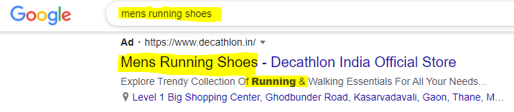
- Focus your headline No 2 on Benefits and Outcomes
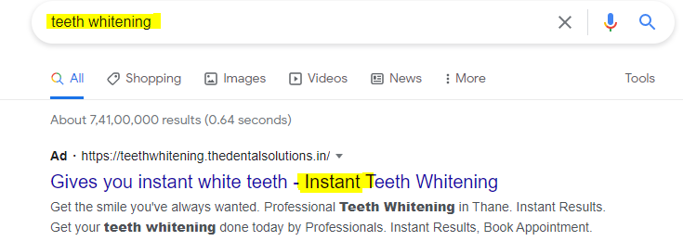
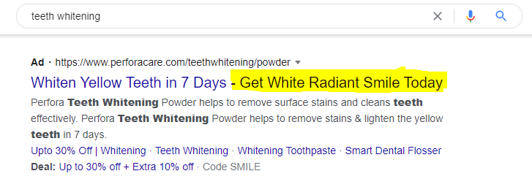
- Include Numbers and statistics in your headlines
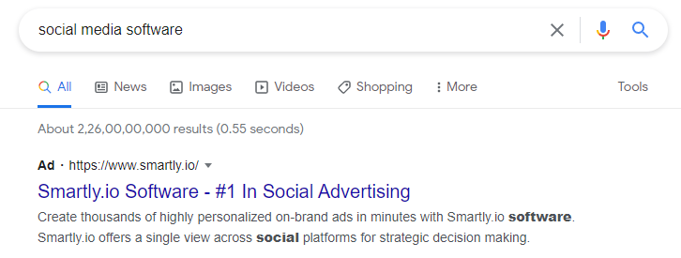
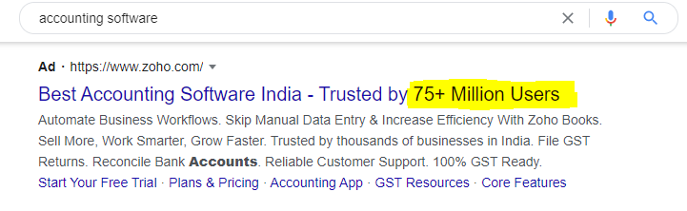
- Handle Objections Preemptively
Handle objections even before the prospect seeks for it, EG below- even before your prospects for it. EG-2 The Advertiser
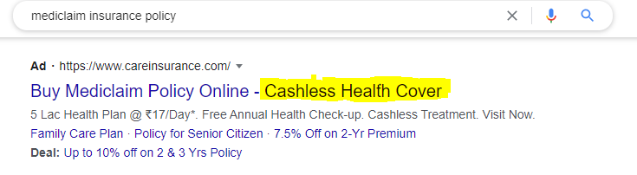
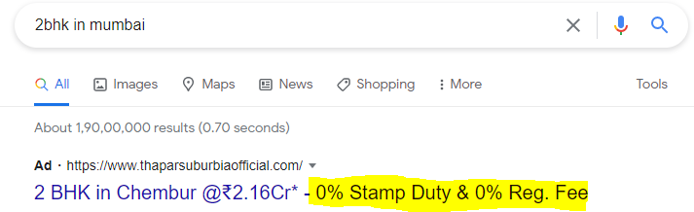

Tell people why they shouldn’t click on your ad
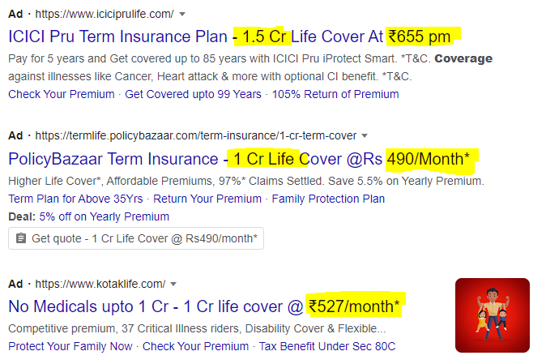

Optimise copy for smaller devices

Google optimises ads differently for mobile devices to fit to the screen size

Write independent headlines, writing interdependent headlines my endure the risk of showing incomplete messages.
- Integrate Power words in your ad copy
- Your
- Free
- Now
- Get
- Online
- Our
- Save
- Best
- Shipping
- You
- Always include a CTA
- Match CTA with CTA on Landing Page
- Ensure Your CTA is dicrectional eg: Instead of using “Download Now” use “ Get A Free Ebook” Eg-2: Instead of using “Enrol now” use “Start Learning”

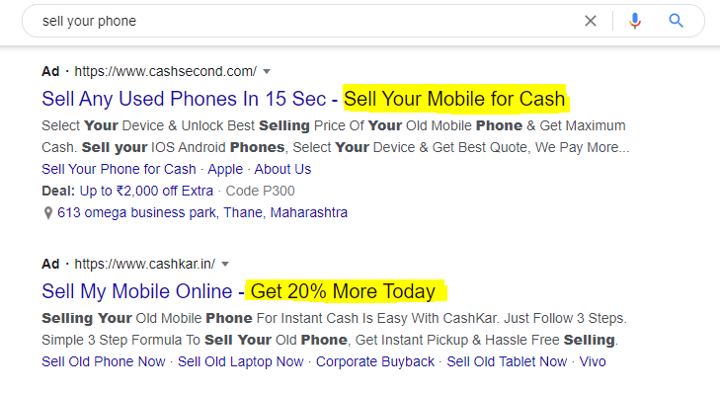
- Include Ratings in your ad copy
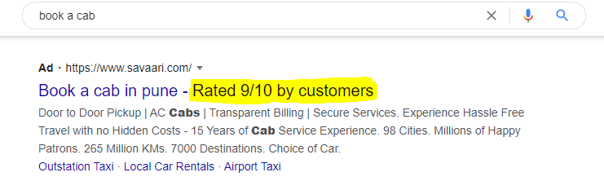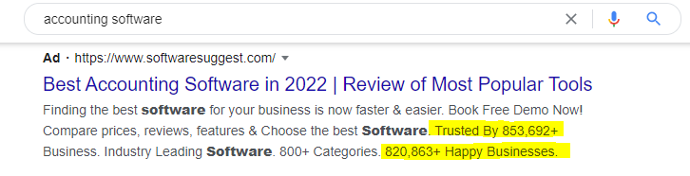
- Double down on Ad Extensions.
- Lead Form extension
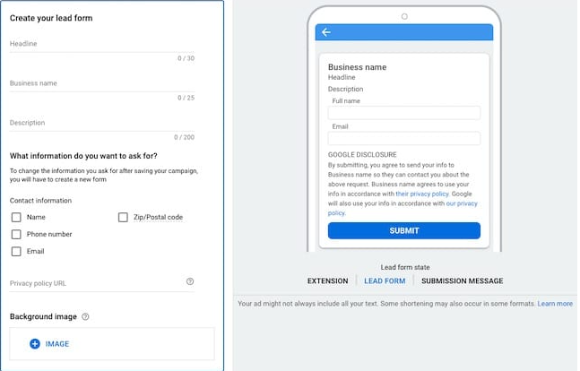
- Call Extension: Ensure that you always have a call extension for Mobile device targeting
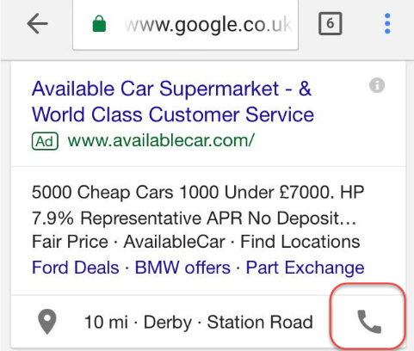
- Callout extensions - Highlight your USP’s

