- Any Word is a Copywriting AI that produces results and generates high converting Ad copies.
It requires basic inputs like Product Name and Product Description and Tone of Voice and based on these inputs it generates best in the class high performing ad copies.
It gives you relevance a relevance score on the right, the higher indicating the most relevant
The below example shows a input for an Email Marketing Software, and the brief details about the product and generate results as displayed on the right.
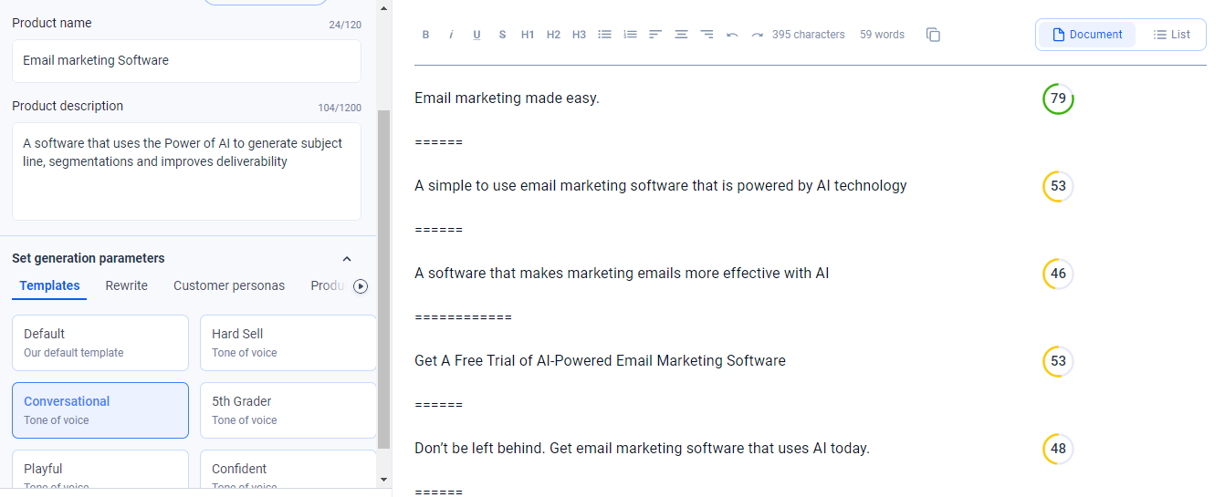

- Unbounce is one of the most reliable and highly copy generator,
It requires a higher array of inputs like Topics, Company name, Language, Brand Audiences and Brand Keywords.
You can experiment with Competitor names while entering the company name filed
Input different languages, optimise specific audiences like Students, Business owners

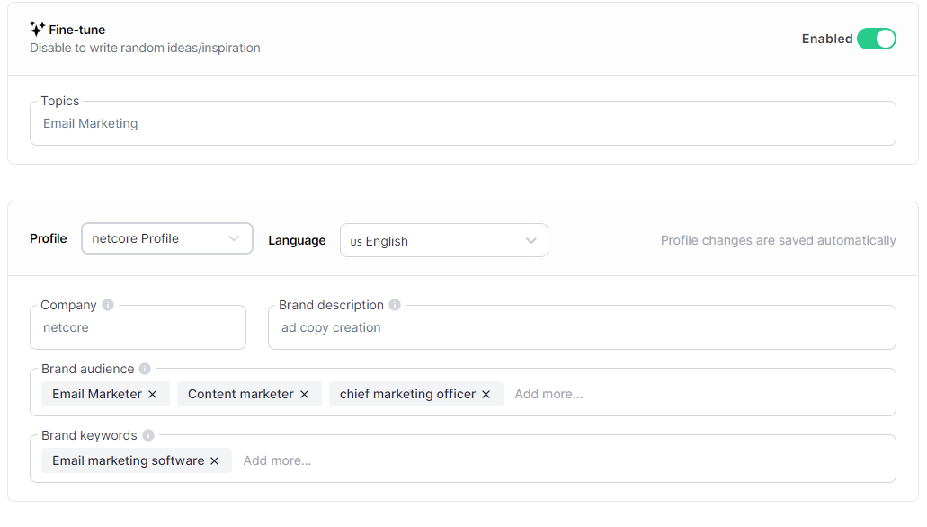
The below section shows the results. This section also has a like and a dislike button. This functions as an additional input generator, how this works is based on your existing likes the tools generated additional copies similar to the ones you liked, hence improving results as and when we go ahead with it.
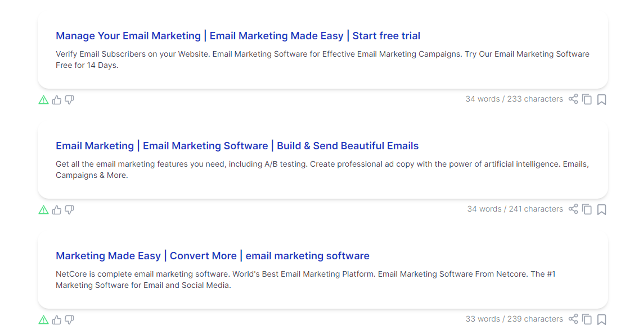

- Storylab.ai Storylab is a rather simple tool, but one of its kind to generate long Descriptions for your ad copies.
With simple Inputs like enter a keyword and a small brief about the product you can generate unlimited descriptions to choose from.
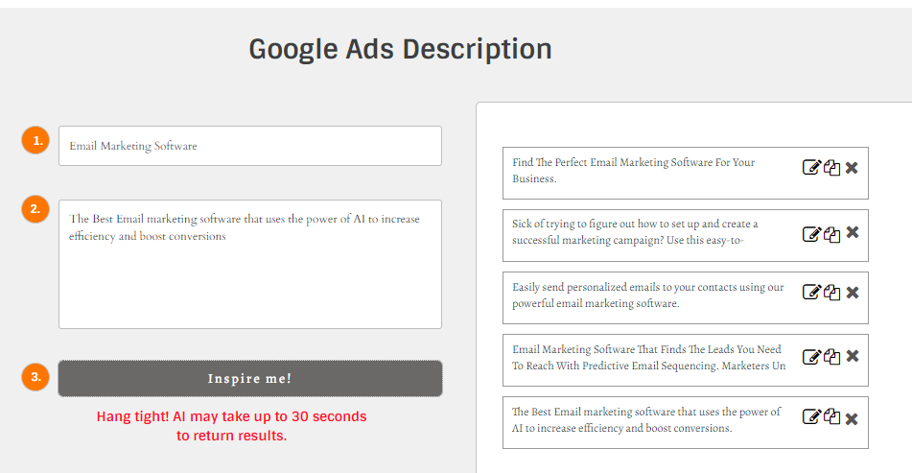
- Brightlocal is a unique way of conducting research and generating copies.
It allows you to enter a keyword, enter the Geography you want to market at and enter the language.
Upon clicking Check results brightlocal gives you a an actual view of how the search would have been had it been conducted from that particular Geo itself.
This provides info with respect to the actual copies used in that particular market and an opportunity to draw inspiration from the same
You can use language option, Specific hooks and tones used by other providers to produce the best results from your own ad copy
